## GTI 531

Finding the power stone took immense loss of a highly technological planet. This protection of purple stone leads to destruction of a whole planet called Xandar. Here the character wants the help from you to deciphate the given graph to find the power stone and accumulate it's power. So to find the power stone you're given vertices with weight and a equation (x +/-/*/% some constant).

You have to find the smallest weighted vertices using any of the greedy algorithm from the source (smallest) to destination (number p) and the path will give you the clue. The path is the number of vertices mentioned and if the there is two vertex of same weight then it must be in the order of occurence.

For example let the table have the vertices (V,T,H,N,D,O,A) and equation,destination be x+6, 4

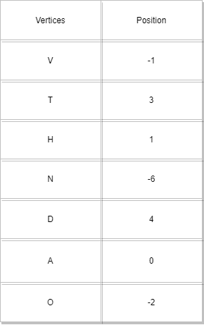

Thus the Source vertex be 0 and Destination vertex be 4. Thus the paths between them are as: V=5, T=9, H=7, N=0, D=10, A=6, O=4 i.e sorted as N,O,...T,D

NOVA first 4 as destination

Thus on the above paths the NOVA is the shortest one and it's to be printed.



**Input Format**

First line contains the number of vertices.

Next n lines contains the path between the vertices and weight of each path such as (a 3) where a is vertix 3 is the weight of the path.

Finally the equation and destination vertices.

**Constraints**

No Constraints

**Output Format**

String

**Sample Input 0**

7

V 5

T 9

H 7

N 0

D 10

A 6

O 4

x+6, 4

**Sample Output 0**

NOVA

**Explanation 0**

The same as the given example above